**Math Dog Game**

**About this app:**

Teachers have innovatively crafted specialized learning tips for young math enthusiasts, blending fun through mixed math games while tailoring the experience to each child’s level of understanding.

**Platforms**:

Android, iOS

**Features**:

Generate questions, confirm the correctness of answers, and provide appropriate responses, including animations, sounds, etc., based on the answers.

**More information:**

**Source code**: https://github.com/ytphi/CSUSB-CSE6550-math4kid-team2

**Author**: Liu, Yutong

**Software used:**

Unity: The evolution of Unity, a licensed game engine utilized for creating video games and various applications, has transformed Unity Technologies into the prominent organization it is today.

**Platforms**:

Android, iOS

**Features**:

3D and 2D graphics support

East to understand architecture

Unity scripting API

Animation Tools

**More information:**

**Source code :** https://unity.com/download

**Author:** Kowser, Sultana

**Visual Studio**:

A Microsoft IDE empowers developers to create apps for desktops, web, mobile, and more.

**Platforms**:

Android, iOS.

**Features**:

Develop

Debug

Test

Collaborate

Extend

**More information:**

Source code : [<https://code.visualstudio.com/download>](https://code.visualstudio.com/download)

Author:

**Math Kids App Screens:**

First Screen:

Home screen displays the game page, and by clicking on the play now button, it directs into the game

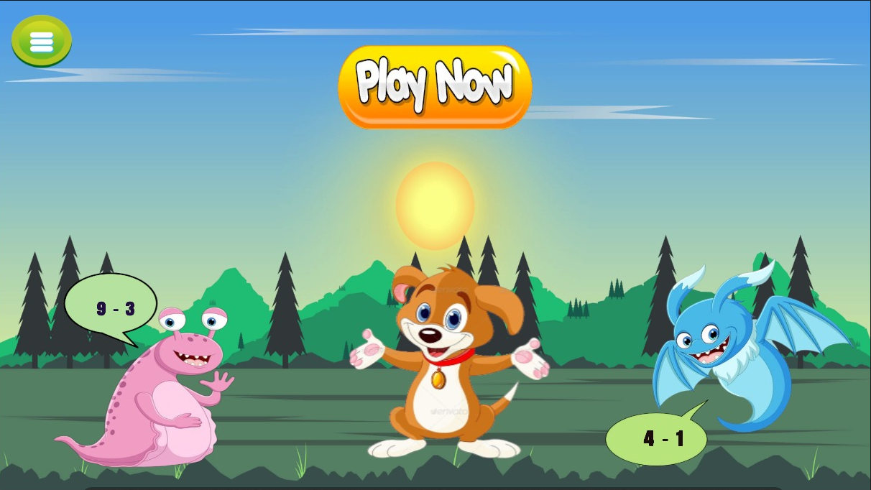

Author: Kowser, Sultana

Second Screen:

By clicking the correct option in the subtracting puzzle, the game moves forward and displays the next question

And, for every correct answer the credit points will be increased

if the answer is wrong it shows try again and redirects back to the question

Author: Kowser, Sultana

Third Screen:

If all the five questions are correct then the screen displays the congratulations page.

Author:

Platforms:

Android, iOS.

Features:

Screens

Questions

Options

Animations

**More information :**

**Source code** :

**Animated Transitions:**

**Platforms**:

Android, iOS.

**Features**:

**More information:**

**Source code**:

**Author**:

**Gaming Store:**

Author:

**Technical Requirements:**

Software engineering tools : Azure DevOps (Boards, Pipeline, Repos, Test Plans, Artifacts)

User interface (UI) programming language : Unity

Programming language : C#

App front-end technology : Unity

App back-end technology : Azure App Service

Integrated development environment (IDE) : Visual Studio for Unity

Software engineering team : Agile team

Google AdMob in-app ads

Nuget Packages

Cloud PaaS : Azure App Service

**Game Algorithm:**

**Platforms**:

Android, iOS

**Features**:

A fun filled educational app for kids to learn

Allows kids to learn subtraction in mathematics

For every correct answer by kid, they earn the reward points

It helps to learn subtraction

**More information:**

Source code:

Author:

**UML Diagrams:**

Graphic representation of system structure, behavior, and relationships using standardized symbols

Platforms:

Android, iOS.

Features :

**More information :**

Source code :

Author:

**SRS:**

Platforms:

Android, iOS.

Features:

**More information:**

Source code:

Author: